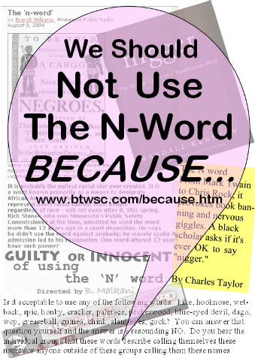
We Should Not Use The N-Word BECAUSE... writing competition
Fancy entering the competition? You can, so long as you're a UK resident, aged 13-17, and can write in NOT MORE THAN 150* words on the topic: 'We Should Not Use The N-Word BECAUSE...'
1. Closing date for entries is Saturday September 30 2006
2. Each entry must include name, age, phone number, email and address of entrant, plus name of a parent or guardian
3. Entries must be emailed to info@btwsc.com, subject line: My N-Word Entry. Email is much preferred, or else, post to BTWSC, P O Box 14092, London NW10 1WL
4. By entering this competition, you give permission for BTWSC to use your entry and image in any way it sees fit to publicise the competition. This includes the right to publish entry on BTWSC's website or any other documents
5. All short-listed entrants will be invited to the award ceremony on Saturday Oct. 14, 6-9pm. Book and CD prizes and cash vouchers will be presented only to entrants who attend, or are represented at ceremony
* BTWSC reserves the right to disqualify entries with total word count of over 150
Venue: Council Chamber, Harrow Civic Centre, Station Road, Harrow, Middlesex, HA1 2XF (Five minutes walk from Harrow & Wealdstone station or 5 minute ride on buses 140, 182, 258, 340 from Harrow On The Hill station)

Entrant’s name Age
Address
Email Phone
Parent/guardian’s name

We should NOT use the N-Word BECAUSE…

